CYB 310 Module 2-2 Lab Worksheet
Andree Salvo
Southern New Hampshire University
CYB 310 – 13007
Instructor: Raschid Muller

The OSI Model
Prompt | Response
What HTTP message type is used to request data? | The HTTP message type is used to request data from a web server.
Identify which flags are set in each of the three segments of the three-way handshake. | - First segment (client > server) > SYN  - Second segment (server > client)> SYN + ACK  - Third segment (client > server) > ACK
What command can be used on a Windows machine to view the MAC address? | On a Windows machine, the command to view a MAC address is ipconfig /all.

Network Troubleshooting
Prompt | Response
In the lab, “Troubleshooting a Suspected DNS issue Using CLI Utilities,” Step 11, type your name after the command prompt and take a screenshot of the output after running the nslookup command. | 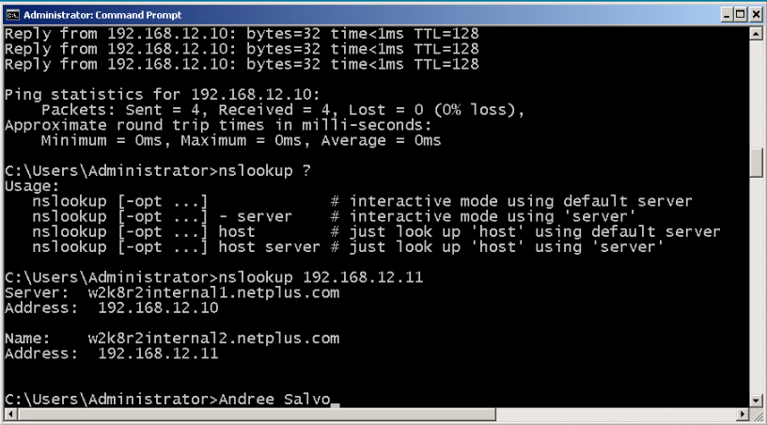
In the lab, “Troubleshooting a Suspected DNS issue Using CLI Utilities,” Step 14, take a screenshot of the webpage after correcting the URL. | 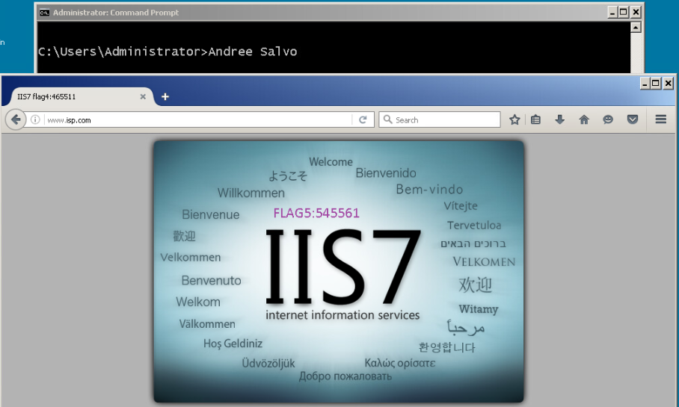
What utility can be used to find out the IP address, subnet mask, and default gateway configured on a computer? | Ipconfig /all
What is the function of the ipconfig/release and the ipconfig/renew commands? | The ipconfig /release command drops the current IP address, while the ipconfig /renew requests a new one from the DHCP server to refresh the network connection.
What type of devices would be better served to have static IP configuration? | Devices like servers, printers, routers, and networked storage systems are better served with a static IP configuration to ensure consistent and reliable access.

TCP/IP Protocols – The Core Protocols
Prompt | Response
In the lab, “Capture and Analyze Transport Layer Protocol Packets,” Step 10, take a screenshot of the output of the field details of the TCP segment. | 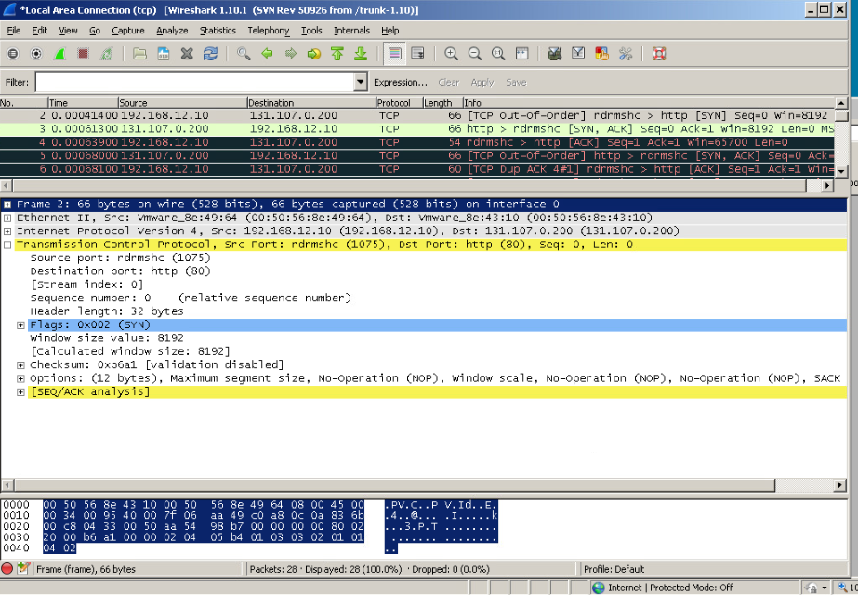
In the lab, “Capture and Analyze a UDP Datagram,” Step 6, take a screenshot of the output of the User Datagram Protocol field details. | 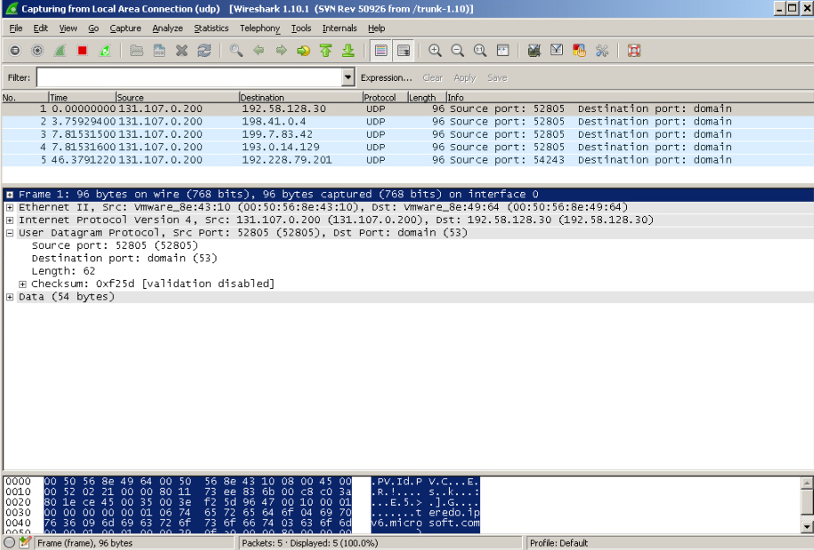
What type of packet is an ARP request? | The ARP protocol maps IP addresses to MAC addresses so that devices on the same local network can communicate. It does this by sending ARP requests (broadcasts) to find the MAC address tied to a given IP, then stores the result in an ARP cache to avoid repeating the process. The arp command lets you view or manage this cache, while the protocol itself defines the structure and meaning of these messages.
What type of packet is an ARP reply? | An ARP reply is a unicast packet sent directly to the requesting host, providing the MAC address that corresponds to the queried IP address.

